Matt Russell, Joshua Ramayrat

Prelab 8

1. **Create an accurate measured drawing that represents the position of each of the drive wheels and each of the line-follower photosensors on your robot. You can hand draw or use CAD. A top projection is acceptable.** 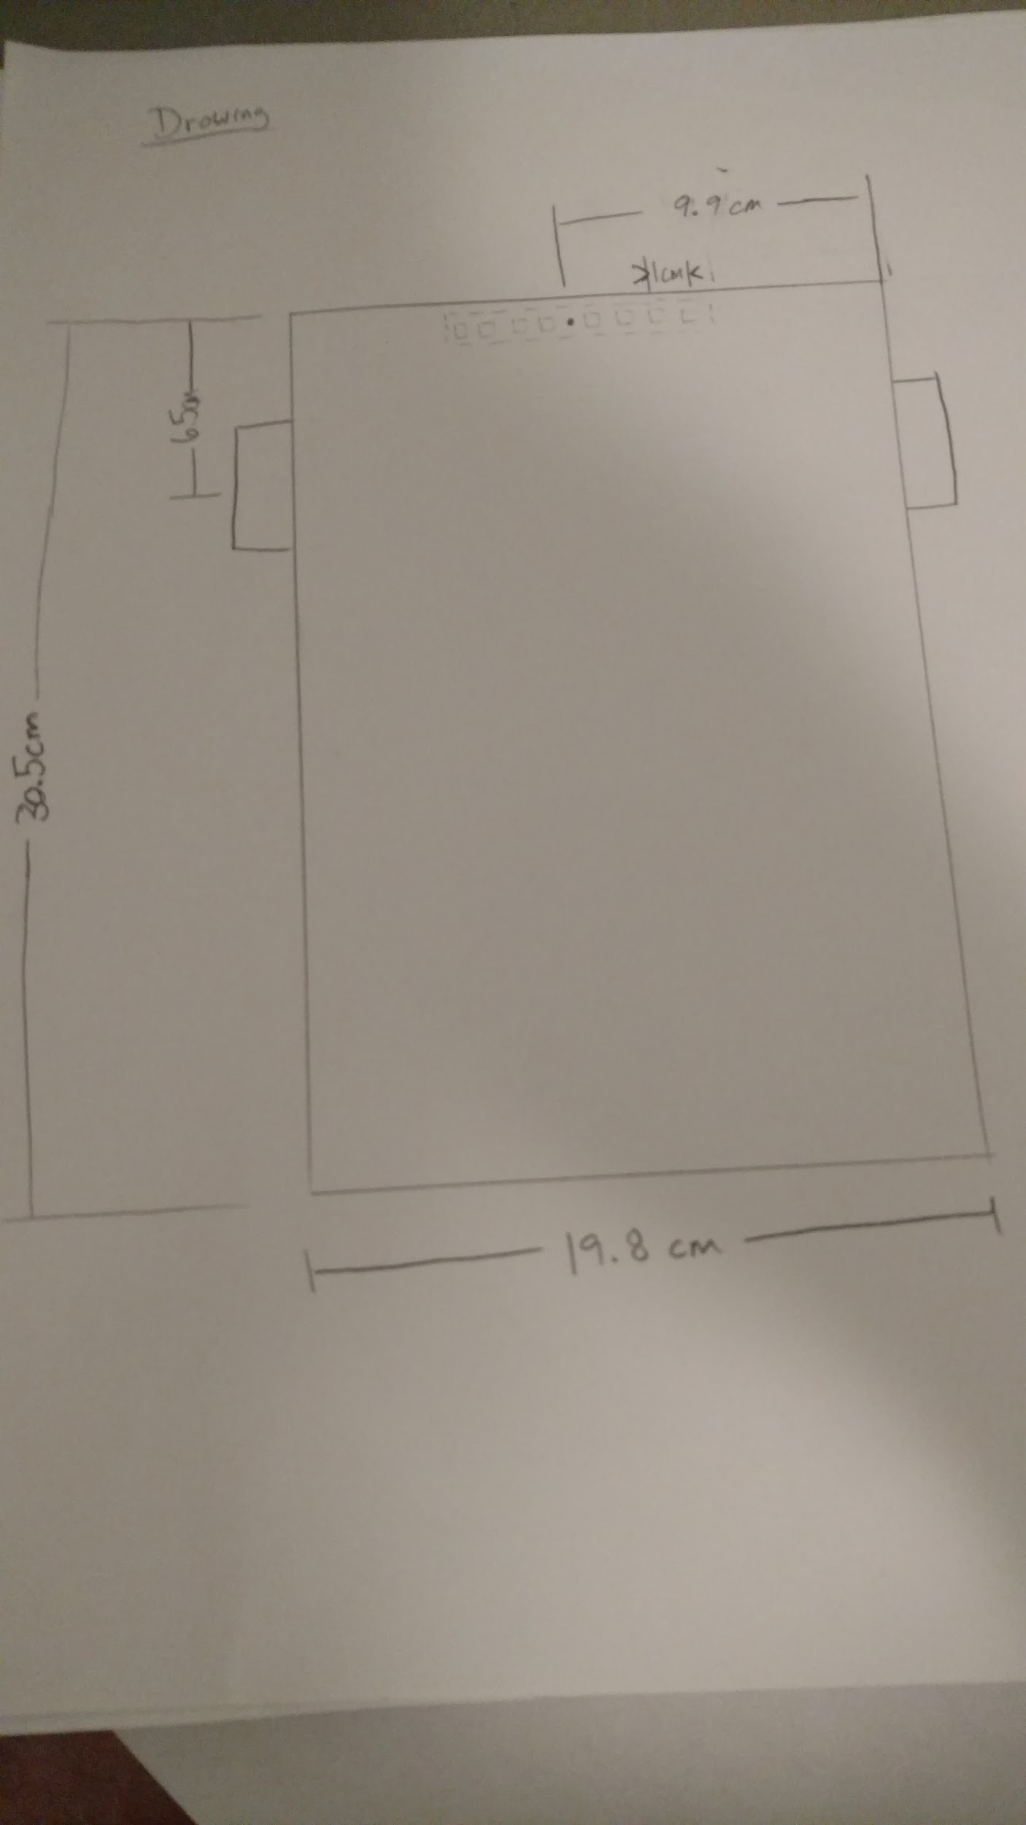

1. **Using these measurements, calculate how the orientation of your robot changes (i.e. the angle), when the right wheel moves forward 1cm and the left wheel simultaneously moves backwards 1 cm.**

Use the equations from last Tuesday’s class:

$φ = \frac{R}{L}2d +φ_{0}$ (d substituted for vt)

$φ = \frac{3}{19.8}2(1) = .303 rad$

1. **Using these measurements, calculate how the orientation of your robot changes (i.e. the angle), when the right wheel moves forward 1cm and the left wheel remains still.**

$φ = \frac{3}{19.8}(1) = .151 rad$

1. **Using these measurements, calculate how the position of each of the 8 photosensors changes (i.e. ΔX and ΔY), when the right wheel moves forward 1cm and the left wheel simultaneously moves backwards 1cm.**

The general equation for ΔX and ΔY for the *kth* photosensor is easily derived from drawing a picture (which we did not upload for space considerations) and doing some trigonometry.

These equations:

${ΔX}_{k}=d_{k}(1-cos(φ))$

${ΔY}_{k}=d_{k}(1-sin(φ))$

Where dk is the distance from the center of the photosensor (because it coincides with our center of rotation) to the *kth* photosensor.

Taking the center of the photosensor to be the origin and referencing the above drawing we can read off the values (with $φ$ =.303 rad)

|  |  |  |
| --- | --- | --- |
| *k* | ${ΔX}_{k}$ (cm) | ${ΔY}_{k}$ (cm) |
| 1 | -.159 | -2.456 |
| 2 | -.114 | -1.754 |
| 3 | -.068 | -1.052 |
| 4 | -.023 | -.351 |
| 5 | .023 | 0.351 |
| 6 | .068 | 1.052 |
| 7 | .114 | 1.754 |
| 8 | .159 | 2.456 |

1. **Using these measurements, calculate how the position of each of the 8 photosensors changes (i.e. ΔX and ΔY), when the right wheel moves forward 1cm and the left wheel remains still.**

The above equations hold true for this case with the caveat that we must take the origin (and thus where dk is referenced from) to be the leftmost edge of the photosensor. We also take $φ$ =.151 rad.

|  |  |  |
| --- | --- | --- |
| *k* | ${ΔX}_{k}$ (cm) | ${ΔY}_{k}$ (cm) |
| 1 | .00057 | 0.425 |
| 2 | .017 | 1.274 |
| 3 | .028 | 2.124 |
| 4 | .039 | 2.974 |
| 5 | .051 | 3.823 |
| 6 | .063 | 4.673 |
| 7 | .074 | 5.522 |
| 8 | .085 | 6.372 |

1. **Selfie**

